**Research Promotion Application:**

To apply to be considered for approval, we ask that you provide us with the following information:

|  |  |
| --- | --- |
| **1. CONTACT DETAILS** | |
| Name of organisation: |  |
| Name and position of contact person: |  |
| Mailing address: |  |
| Contact number/s: |  |
| Email: |  |
| Name/s of lead investigators or supervisor: |  |
| Contact details for participant enquiries (if this is the same as the contact details above, please leave blank) | Name, Number, Email. |

**Before completing your application, please ensure your project details (including any flyers, images and advertising materials) are in accordance Endometriosis Australia’s language and ethics policy below:**

1. Unless gender is somehow relevant the study (e.g looking at trans experiences of healthcare) we ask that all language is inclusive – both the text and the graphic.
   1. Inclusive language when describing/addressing people who have endometriosis. This can include the following statements:
      1. People/Individuals
      2. Women and those assigned female at birth (AFAB)
      3. Women, trans men, non-binary, and gender diverse people*

*\*Please note if you choose 1.1.3. you must include all listed all above. This is because not all people who identify as non-binary necessarily identify as gender-diverse and vice versa.*

1. The graphic/image for your study must:
   1. Be a square or horizontal graphic
   2. Include the ethics approval number
   3. Name or logo of institution
   4. Have minimal text on graphic (otherwise will be difficult to read).

**PLEASE SEE APPENDIX 1 FOR AN EXAMPLE**

**Please tick box below**

* I confirm that my project details and attached materials are in accordance with Endometriosis Australia’s language and ethics policy.

|  |  |
| --- | --- |
| **2. PROJECT DETAILS** | |
| Name of project: |  |
| Have you received ethics approval? | __ Yes (attached)  __ No |
| What are the eligibility criteria to participate? (age, location, co-existing conditions, etc) |  |
| Project location details (is it an Australia wide study? Is it state restrictive? Or is it international?) |  |
| What are the dates for your project? | Start date: ______/______/______  End date: ______/______/______ |
| Short promotion bio (no more than 100 words) including mention of Endometriosis Australia as a supporter of your research/study. |  |
| Please describe what participants are required to do during this research, including information on access, time commitment required, etc.  NB: If your research projects includes a survey, please include all relevant links. |  |
| Participation in this research activity is via: | Online  Phone  In Person  Other – please describe: |
| Please provide your social media handles you wish to use for promotion | Instagram:  Facebook:  Twitter: |

|  |  |  |
| --- | --- | --- |
| **2. PARTICIPATION & RECRUITMENT DETAILS** | | |
| *How* are people participating in this research activity  (*i.e. please provide us with: link to survey/tool, or email, or phone number, etc., that people will need to access to participate).* | Online | LINK to survey/tool: ___________  (If using QR code, please still provide link) |
| In Person | Email or link to sign-up: ________ |
| Phone | Number:___________ |
| Other – *please describe:* |  |
| How many participants do you plan to recruit? |  | |
| How many participants have you recruited to date? |  | |

|  |  |
| --- | --- |
| **3. BUDGET & ADVERTISING** | |
| **Promotion Fees: (Mandatory)**  **A $50.00 + GST** administration fee is payable for all research promotion. Our research promotion analytics and testimonials attached below at APPENDIX 2.  Fees will include:   1. A once-only organic social media post on Instagram and Facebook. 2. Inclusion of your research on our website’s [Research Notice Board.](https://endometriosisaustralia.org/research-notice-board/) 3. Story highlight in our monthly email newsletter. | |
| **Advertising Fees: (Optional)**  In addition to organic reach from Promotion Fees, paid advertising is available across our Facebook and Instagram channels should you wish to increase promotion research of your research.  Advertising Fees are charged at cost with the addition of a flat service fee of $25 + GST. Please advise your preferred advertising fees below. | * None * $100 + GST Advertising Fee + Service Fee of $25 + GST = **$125 + GST** * $150 + GST Advertising Fee + Service Fee of $25 + GST = **$175 + GST** * $200 + GST Advertising Fee + Service Fee of $25 + GST = **$225 + GST** |
| **If selected an additional advertising fee:**  Please add the length of campaign you would like to promote?  *i.e. would you like to spend your budget in 1 week or across multiple weeks?* | * 1 week * 2 weeks * 3 weeks * 4 weeks |
| Endometriosis Australia can provide an analytics report, with a summary of your research’s paid advertising performance one week after closure of your projects end date.  Please indicate if you are interested in receiving a post Advertising report. | * Yes, I would like to receive the paid advertising analytics * No, I do not need to receive analytics on our paid advertising |

**Attachment Checklist:**

* Image/Graphic for promotion which you own full rights to (See Appendix 1 for example).
* A copy of your ethics approval (Note your application will be declined if not obtained)

**Terms and Conditions**

1. I/We agree to acknowledge the role of Endometriosis Australia in assisting recruitment for this project and include mention of Endometriosis Australia as a supporter of our research within our published report.
2. I/We confirm the research project seeking promotion pertains to the study and exploration of endometriosis.
3. I/We agree to communicate with participants the outcomes of project acknowledging their contribution of time and lived experience.
4. I/We agree to provide Endometriosis Australia with the projects published report as well as a laypersons summary of findings for the purpose of reporting back and educating their community.
5. I/We declare the project has gained ethics approval which is attached for Endometriosis Australia’s records.

I, the undersigned, acknowledge that I have read, and agree to Endometriosis Australia’s terms and conditions above. I confirm that the above provided information is true and accurate. I also confirm that I have attached the requested required documentation to this return form.

I, the undersigned,

Name ______________________________________________

Signature___________________________________________

Date_______________________________________________

**Next Steps:**

Please return this completed application, and all relevant attachments to [admin@endoaustralia.org](mailto:admin@endoaustrlia.org).

Once we have received your completed application, we will review this for approval. Whilst we aim to respond to your request as soon as possible, please allow up to one week for us to review your application.

If your application is approved, we will provide you with an invoice for the above noted promotion fee and your chosen advertising fees. We will also request that you send a receipt as confirmation of the transfer of these funds.

**APPENDIX 1:**

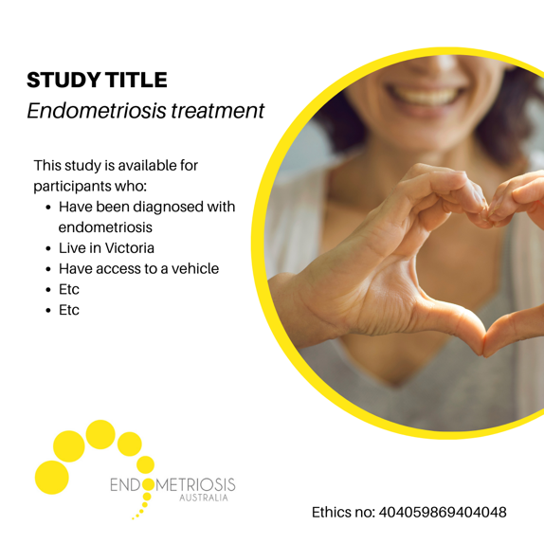

**APPENDIX 2**

**